Time series And Factor Analysis
ASSESSMENT – 2
Parag Soni – R00208553

PCA

PCA is a unsupervised machine learning technique used to find principal component i.e., linear combination of predictive variables that explain a large portion of the variation in a dataset. In laymen terms the goal of PCA is to explain most of the variability in a dataset with fewer variables than the original dataset.
So for a given dataset in our case decathlon.
In order to calculate the linear combinations of the original predictors:

1. Scale each of the variables to have a mean of 0 and a standard deviation of 1.

2. Calculate the covariance matrix for the scaled variables.

3. Calculate the eigenvalues of the covariance matrix where eigenvalues represent the variance.

Step 1: Load the Data
Correlation between variables:
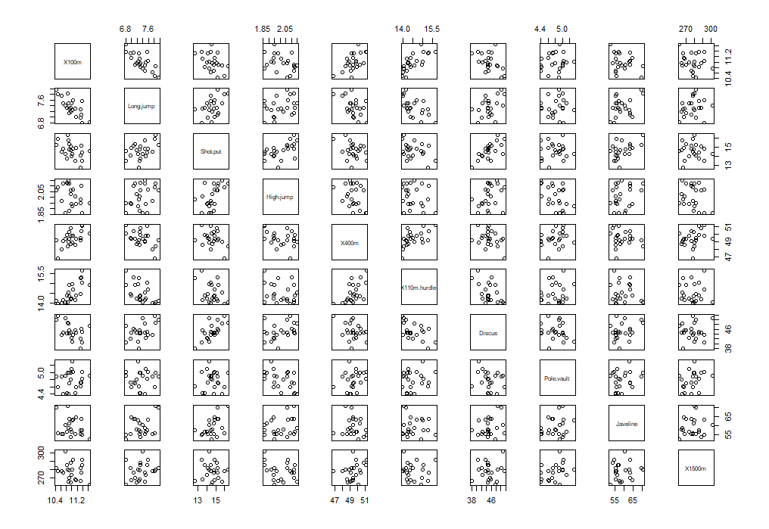
It is seen that variables are correlated to each other.

Question 2
Bartlett's test of sphericity suggests that there is sufficient significant correlation in the data for factor analysis (Chisq(45) = 100.39, p < .001).

Step 2: Calculate the Principal Components
After loading the given decathlon dataset, we have used the R built-in function prcomp() and PCA() to calculate the principal components of the dataset. We will keep scale = TRUE so that each of the variables in the dataset are scaled to have a mean of 0 and a standard deviation of 1 before calculating the principal components. Also centring it.
Question 3 a)
Comparing Eigen values of both:

Eigen values for PCA
 | eigenvalu | percentage of varianc | cumulative percentage of variance
comp 1 | 4.1242133 | 41.242133 | 41.24213
comp 2 | 1.8385309 | 18.385309 | 59.62744
comp 3 | 1.2391403 | 12.391403 | 72.01885
comp 4 | 0.8194402 | 8.194402 | 80.21325
comp 5 | 0.7015528 | 7.015528 | 87.22878
comp 6 | 0.4228828 | 4.228828 | 91.4576
comp 7 | 0.3025817 | 3.025817 | 94.48342
comp 8 | 0.27447 | 2.7447 | 97.22812
comp 9 | 0.1552169 | 1.552169 | 98.78029
comp 10 | 0.121971 | 1.219710 | 100

Eigen values for prcomp()
 | eigenvalue | variance.percent | cumulative.variance.percent
Dim.1 | 4.1242133 | 41.242133 | 41.24213
Dim.2 | 1.8385309 | 18.385309 | 59.62744
Dim.3 | 1.2391403 | 12.391403 | 72.01885
Dim.4 | 0.8194402 | 8.194402 | 80.21325
Dim.5 | 0.7015528 | 7.015528 | 87.22878
Dim.6 | 0.4228828 | 4.228828 | 91.4576
Dim.7 | 0.3025817 | 3.025817 | 94.48342
Dim.8 | 0.27447 | 2.7447 | 97.22812
Dim.9 | 0.1552169 | 1.552169 | 98.78029
Dim.10 | 0.121971 | 1.21971 | 100

It is seen that from the output the eigen values for both the commands are same.

Question 3 b)

Plot using PCA
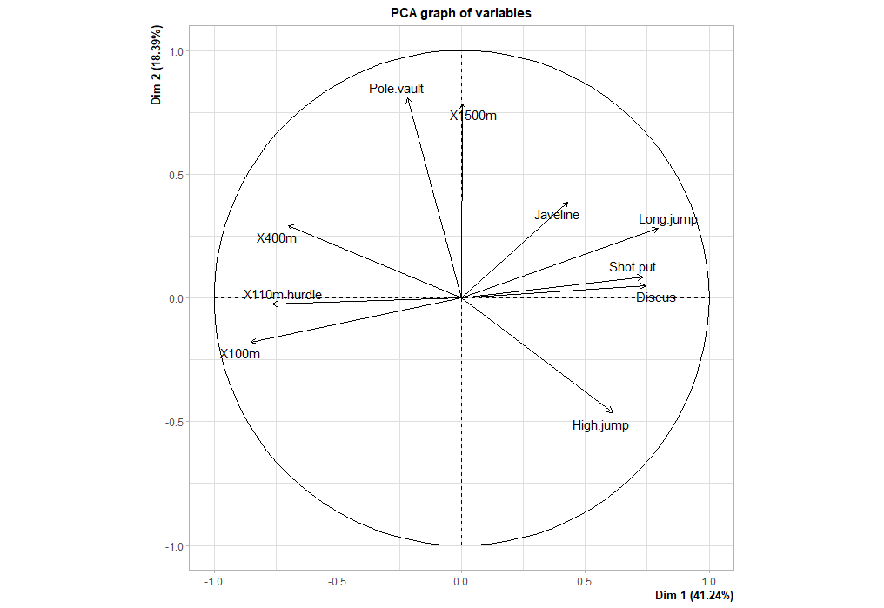

 | Dim.1 | Dim.2 | Dim.3 | Dim.4 | Dim.5
SEBRLE | 0.195505 | 1.589057 | 0.642491 | 0.083897 | 1.168294
CLAY | 0.80788 | 2.474814 | -1.38738 | 1.298382 | -0.82498
BERNARD | -1.35913 | 1.648095 | 0.200558 | -1.96409 | 0.084193
YURKOV | -0.88895 | -0.44261 | 2.529584 | 0.712908 | 0.407823
ZSIVOCZKY | -0.10812 | -2.06884 | -1.33426 | -0.10153 | -0.20145
McMULLEN | 0.12122 | -1.01391 | -0.86252 | 1.341643 | 1.62151286>

Here PC1 and PC2 are mentioned as Dim.1 and Dim.2
Pc1 has javelin, shotput, longjup, discus, highjump, x400, x100,x100 hrdle related to each other
While pc2 explains relation between mainly x500 and pole vault

Question 3 c)
For PCA
$cor
Dim.1 Dim.2 Dim.3 Dim.4 Dim.5
X100m -0.850625692 -0.17939806 0.30155643 0.03357320 -0.1944440
Long.jump 0.794180641 0.28085695 -0.19054653 -0.11538956 0.2331567
Shot.put 0.733912733 0.08540412 0.51759781 0.12846837 -0.2488129
High.jump 0.610083985 -0.46521415 0.33008517 0.14455012 0.4027002
X400m -0.701603377 0.29017826 0.28353292 0.43082552 0.1039085
X110m.hurdle -0.764125197 -0.02474081 0.44888733 -0.01689589 0.2242200
Discus 0.743209016 0.04966086 0.17652518 0.39500915 -0.4082391
Pole.vault -0.217268042 0.80745110 0.09405773 -0.33898477 -0.2216853
Javeline 0.428226639 0.38610928 0.60412432 -0.33173454 0.1978128
X1500m 0.004278487 0.78448019 -0.21947068 0.44800961 0.2632527
Using PRcomp()
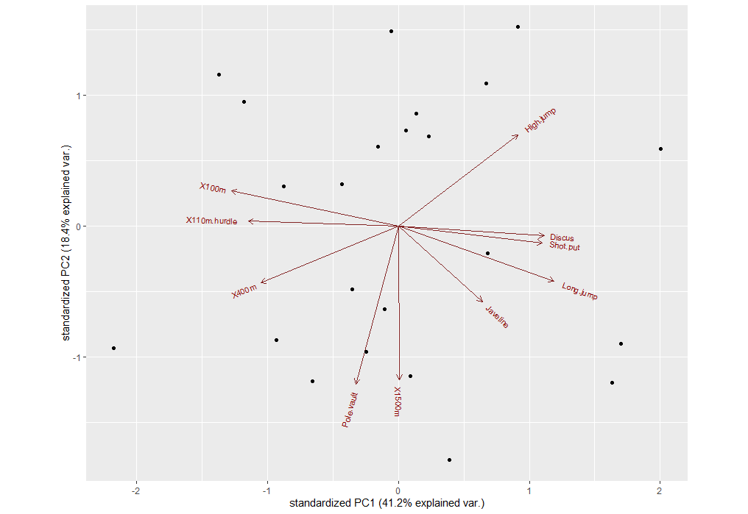

Step 4: Find Variance Explained by Each Principal Component
From the results we can observe the following:
OUTPUT
Importance of components:
PC1 PC2 PC3 PC4 PC5 PC6 PC7 PC8 PC9 PC10
Standard deviation 2.0308 1.3559 1.1132 0.90523 0.83759 0.65029 0.55007 0.52390 0.39398 0.3492
Proportion of Variance 0.4124 0.1839 0.1239 0.08194 0.07016 0.04229 0.03026 0.02745 0.01552 0.0122
Cumulative Proportion 0.4124 0.5963 0.7202 0.80213 0.87229 0.91458 0.94483 0.97228 0.98780 1.0000
The first principal component explains 41% of the total variance in the dataset.
The second principal component explains 18% of the total variance in the dataset.
The third principal component explains 12% of the total variance in the dataset.
The fourth principal component explains 8% of the total variance in the dataset.
Thus, the first two principal components explain a majority of the total variance in the data.

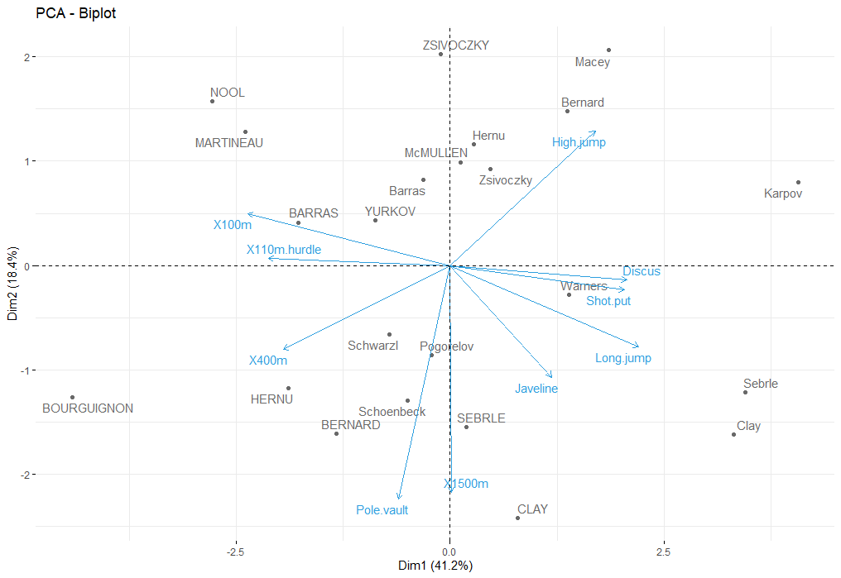

For PC1 – it mainly represent Discus, shotput, longJump, javelin, high jump on positive side and X100m, X100m.hurdle , X400 on negative side
For PC2 - It represent highjump on positive and pole.vault, X1500, javelin, X400 on negative sides.

Question 3 d)
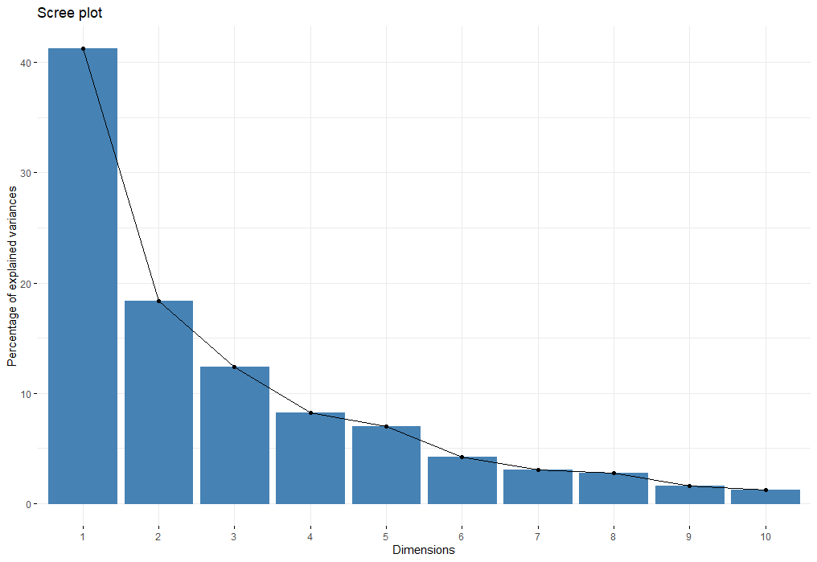
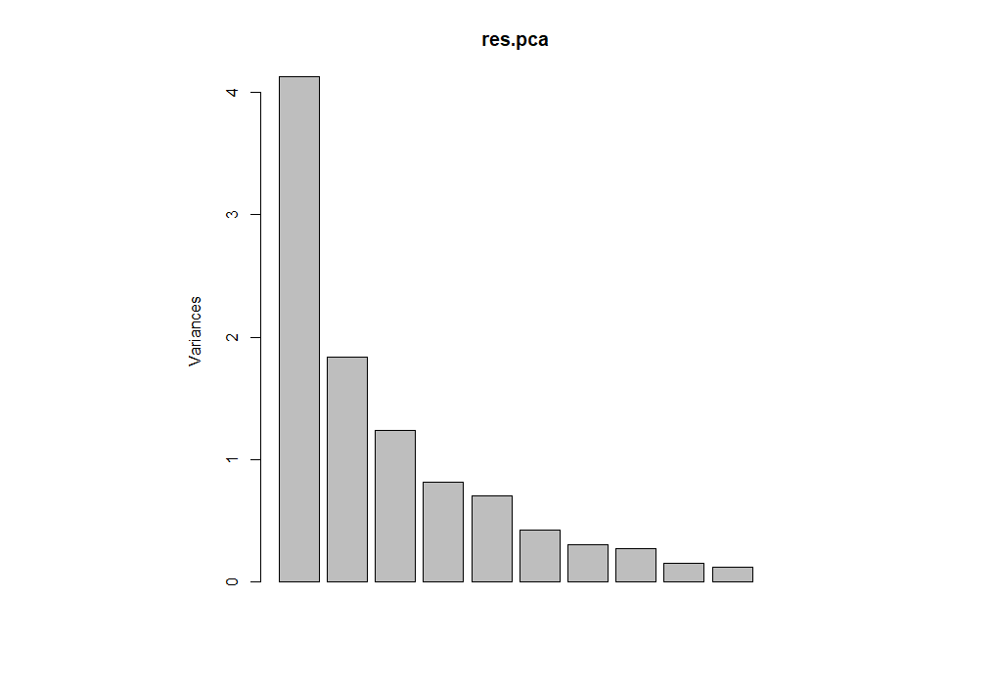
We can retain 3 components as the variance of 3 components are greater than 1.

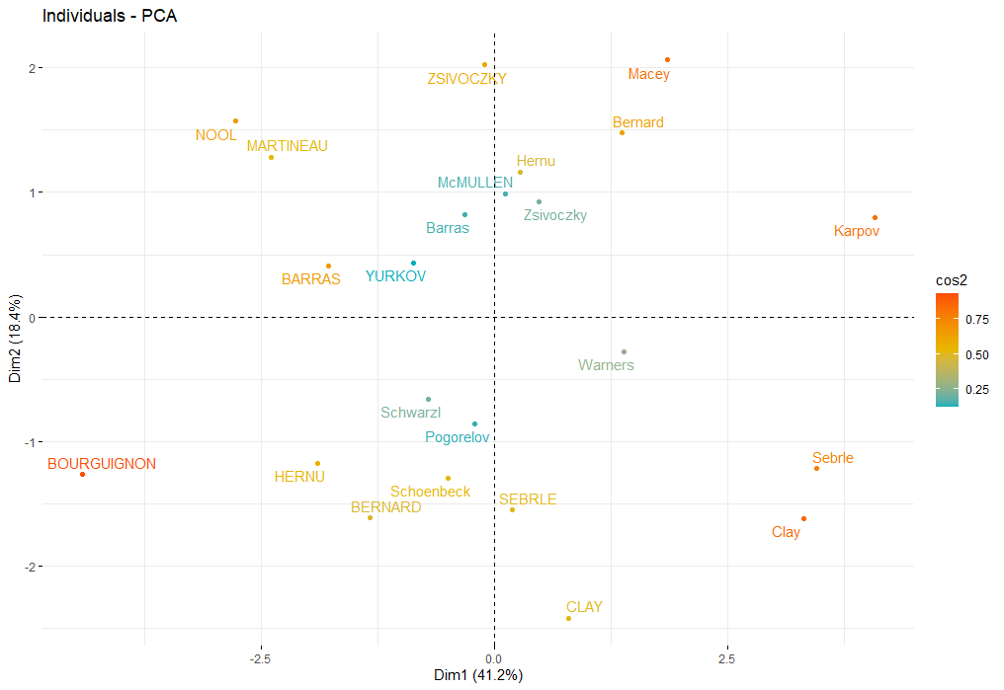
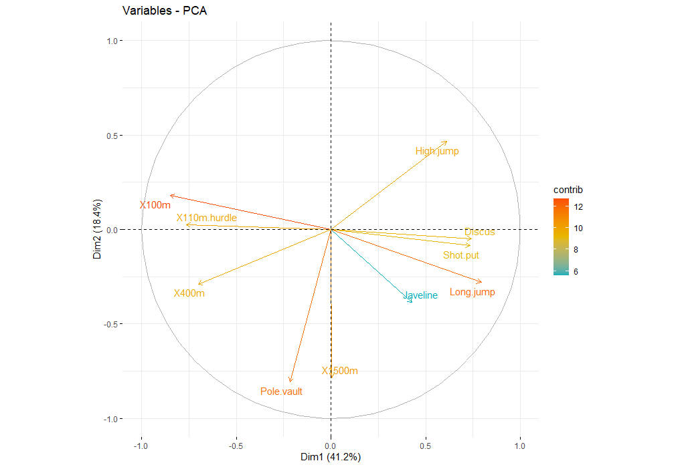

So, we got 3 principal components with their standard deviation, Proportion of variance and cumulative variance

We can see that the first principal component (PC1) has high values for high jump, discus, shotput, lonh jump which indicates that this principal component describes the most variation in these variables.
Question 3 e)

Scores
Scores are linear combinations of the data that are determined by the coefficients for each principal component. To obtain the score for an observation, substitute its values in the linear equation for the principal component.
Long.jump 0.794180641 -0.11538956 0.2331567
0.12846837 -0.2488129
0.14455012 0.4027002
0.43082552 0.1039085
-0.01689589 0.2242200
0.39500915 -0.4082391
-0.33898477 -0.2216853
-0.33173454 0.1978128
0.44800961 0.2632527

PC score
For PC1
X100m *--0.850625692 + Long.jump 0.794180641 + Shot.put 0.733912733 + High.jump 0.610083985 + X400m * -0.701603377 + X110m.hurdle *-0.764125197 + Discus 0.743209016 + Pole.vault -0.217268042 + Javeline 0.428226639 + X1500m 0.004278487

For PC2
X100m *-0.17939806 + Long.jump 0.28085695 + Shot.put 0.08540412 + High.jump -0.46521415+ X400m * 0.29017826 + X110m.hurdle * -0.02474081+ Discus * 0.04966086 + Pole.vault * 0.80745110 + Javeline * 0.38610928 + X1500m * 0.78448019

For PC3
X100m *0.30155643 + Long.jump -0.19054653 + Shot.put 0.51759781 + High.jump * 0.33008517 + X400m * 0.28353292 + X110m.hurdle *0.44888733 + Discus *0.17652518 + Pole.vault *0.09405773 + Javeline *0.60412432 + X1500m *-0.21947068

Question 4
Output of applying factanal()
Call:
factanal(x = decathlon2.active, factors = 3)

Uniquenesses:
X100m Long.jump Shot.put High.jump X400m X110m.hurdle Discus Pole.vault Javeline
0.096 0.341 0.005 0.444 0.563 0.402 0.416 0.005 0.710
X1500m
0.757

Loadings:
Factor1 Factor2 Factor3
X100m 0.915 -0.249
Long.jump -0.746 0.291 0.132
Shot.put -0.231 0.966
High.jump -0.338 0.418 -0.517
X400m 0.621 -0.161 0.158
X110m.hurdle 0.742 -0.215
Discus -0.395 0.617 -0.218
Pole.vault 0.207 0.166 0.962
Javeline -0.166 0.475 0.190
X1500m -0.186 0.454

Factor1 Factor2 Factor3
SS loadings 2.761 1.962 1.538
Proportion Var 0.276 0.196 0.154
Cumulative Var 0.276 0.472 0.626

Test of the hypothesis that 3 factors are sufficient.
The chi square statistic is 13.6 on 18 degrees of freedom.
The p-value is 0.754

The command tells 3 factors are sufficient as we observed from previous findings.

b)
section is the loadings, which range from −1 to 1. This is the Λ^ in the equation above. The loadings are the contribution of each original variable to the factor. Variables with a high loading are well explained by the factor. Notice there is no entry for certain variables. That is because R does not print loadings less than 0.1. This is meant to help us spot groups of variables.
SS loadings gives the sum of squared loadings. This is sometimes used to determine the value of a particular factor. A factor is worth keeping if the SS loading is greater than 1 (Kaiser’s rule).
From above output if the variance explained by variable is greater than 7 says that the factor extracts sufficient variance from that variable.

Question 3 c)
Factor Analysis using method = minres
Call: fa(r = decathlon2.active, nfactors = 2, rotate = "varimax",
fm = "minres")
Standardized loadings (pattern matrix) based upon correlation matrix
MR1 MR2 h2 u2 com
X100m -0.87 -0.01 0.76 0.24 1.0
Long.jump 0.82 0.11 0.68 0.32 1.0
Shot.put 0.66 -0.09 0.45 0.55 1.0
High.jump 0.47 -0.52 0.49 0.51 2.0
X400m -0.59 0.36 0.48 0.52 1.6
X110m.hurdle -0.71 0.11 0.52 0.48 1.0
Discus 0.67 -0.11 0.47 0.53 1.1
Pole.vault -0.06 0.75 0.57 0.43 1.0
Javeline 0.41 0.17 0.19 0.81 1.3
X1500m 0.13 0.61 0.39 0.61 1.1

MR1 MR2
SS loadings 3.59 1.42
Proportion Var 0.36 0.14
Cumulative Var 0.36 0.50
Proportion Explained 0.72 0.28
Cumulative Proportion 0.72 1.00

Mean item complexity = 1.2
Test of the hypothesis that 2 factors are sufficient.

The degrees of freedom for the null model are 45 and the objective function was 5.63 with Chi Square of 100.39
The degrees of freedom for the model are 26 and the objective function was 1.85

The root mean square of the residuals (RMSR) is 0.1
The df corrected root mean square of the residuals is 0.13

The harmonic number of observations is 23 with the empirical chi square 20.79 with prob < 0.75
The total number of observations was 23 with Likelihood Chi Square = 30.47 with prob < 0.25

Tucker Lewis Index of factoring reliability = 0.838
RMSEA index = 0.074 and the 90 % confidence intervals are 0 0.198
BIC = -51.05
Fit based upon off diagonal values = 0.93
Measures of factor score adequacy
MR1 MR2
Correlation of (regression) scores with factors 0.95 0.86
Multiple R square of scores with factors 0.91 0.74
Minimum correlation of possible factor scores 0.81 0.48

Using Fa function there are only 2 factors while we observed 3 from factonal function.
Question 3 d)
Factor analysis
So we apply “fa.parallel” function from the “nFactors” package in r to identify number of factors and the number of components.

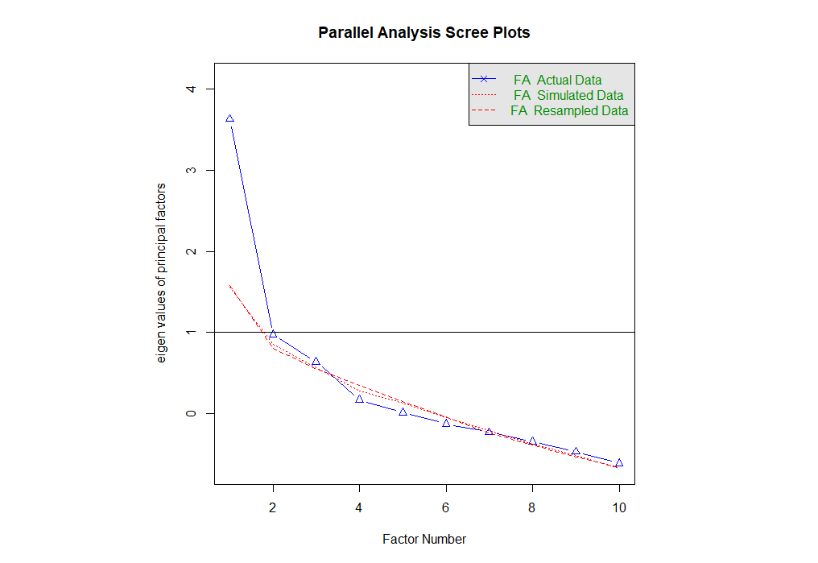
It says we can have only 1 vecctor because only 1 vector has eigen value greater than 1.
Question 3 e)

Fa.diagram() plot
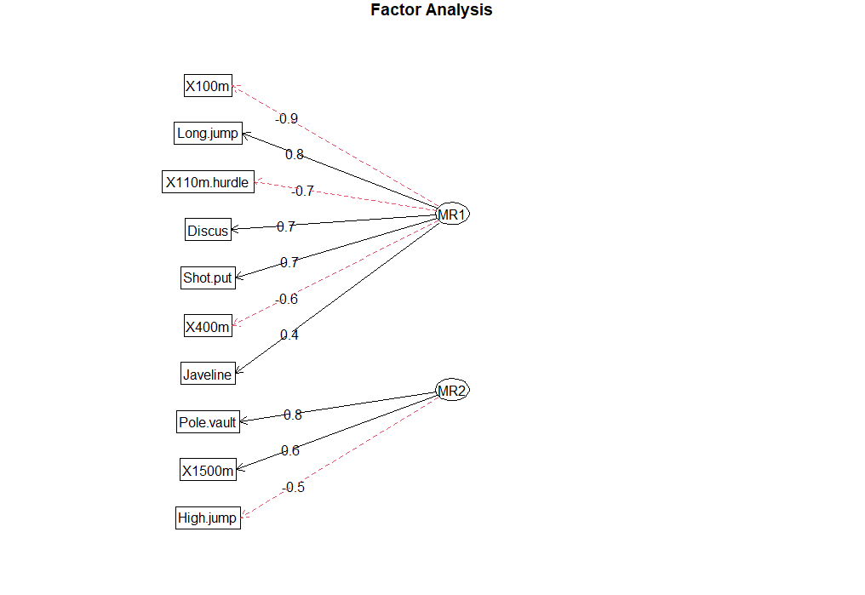
It says that there are 2 factors and is same as our PCA output.
X100*0.9 + longJump*0.8 + X110 *0.7 +discus*0.7 +shotput*0.7+X400*0.6+javelin*0.4 = mr1
Pole vault* 0.8 + X1500 *0.6 + high Jump* 0.5 = mr2

Our plot is like below:

The process of transforming a factor pattern is generally referred to as rotation. There are two basic types of transformations: orthogonal (uncorrelated factors) and oblique (correlated factors). Using orthogonal rotation, we preserve the independence of the factors. With oblique rotation factors are allowed to correlate. Two poplar methods are the varimax method for orthogonal factor transformation, and the promax method for oblique factors rotation.
I have used varimax method, it maximizes the variance of the squared loadings for each factor, thus making some of these loadings as large as possible, and the rest as small as possible in absolute value. Consequently, the variables become divisible into groups such that the loadings within each group are high on a single factor, moderate to low on a few factors and negligible on the remaining factors

The next
Applying “fa” function gives us variances for 2 pricipal component or factors as MR1 and MR2, communality as column “h2” and uniqueness as “u2”.
Uniqueness is the variance that is 'unique' to the variable and not shared with other variables. It is equal to 1 – communality which is the variance that is shared with other variables.
communality are between o and 1 and Tells what % of the original variability
is explained by the extracted factors

